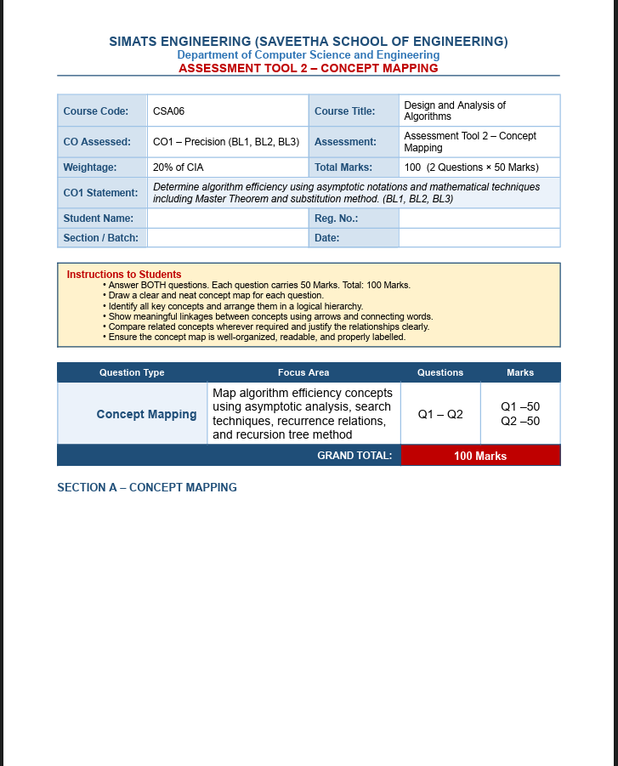



Q3. Concept Map: Recurrence Relation → Substitution Method → Expansion → Complexity Derivation
Extended Concept Map:
Recurrence Relation
│
▼
Substitution Method
│
▼
Guess the Solution
│
▼
Expansion (Repeated Substitution)
│
▼
Induction
│
▼
Verification
│
▼
Closed-Form Solution
│
▼
Complexity Derivation
│
▼
Algorithm Efficiency (Big-O)

Explanation of Each Connection
- Recurrence Relation → Substitution Method
  - A recurrence relation expresses the running time of a recursive algorithm.
  - The substitution method is chosen to solve the recurrence.
- Substitution Method → Guess the Solution
  - First, assume (guess) a possible closed-form solution, such as O(n log n) or O(n²).
- Guess → Expansion
  - Expand the recurrence by repeatedly substituting the recursive term.
  - This reveals a pattern that supports or improves the guessed solution.
- Expansion → Induction
  - Use mathematical induction to prove that the guessed solution holds for all values of n.
- Induction → Verification
  - Verify that the solution satisfies both the recurrence relation and the base case.
  - If it fails, modify the guess and repeat.
- Verification → Closed-Form Solution
  - After successful proof, obtain the final mathematical expression for the recurrence.
- Closed-Form Solution → Complexity Derivation
  - Express the dominant term using asymptotic notation such as O(), Θ(), or Ω().
- Complexity Derivation → Algorithm Efficiency
  - The derived complexity indicates how efficiently the algorithm performs as the input size grows.
  - Lower complexity means better scalability and performance.

Example
Given:
[
T(n)=2T(n/2)+n
]
- Guess: (T(n)=O(n\log n))
- Expand: (T(n)=2[2T(n/4)+n/2]+n=4T(n/4)+2n)
- Continue expansion until the base case.
- Induction & Verification: Prove the guess is correct.
- Closed Form: (T(n)=\Theta(n\log n))
- Efficiency: The algorithm runs in Θ(n log n) time, making it efficient for large inputs.

Q4. Concept Map: Algorithm → Input Size (n) → Growth Rate → Efficiency
Extended Concept Map:
Algorithm
│
▼
Input Size (n)
│
▼
Growth Rate
│
├──────────────► Asymptotic Notations (O, Θ, Ω)
│
▼
Efficiency
│
▼
Scalability

Explanation of Each Node
- Algorithm → Input Size (n)
  - Every algorithm processes an input.
  - The value of n represents the size of the input (number of elements, records, etc.).
- Input Size (n) → Growth Rate
  - As n increases, the number of operations performed by the algorithm also changes.
  - This change is called the growth rate.
- Growth Rate → Asymptotic Notations
  - Asymptotic notations describe the growth mathematically:
    - O (Big-O): Upper bound (worst case)
    - Θ (Theta): Exact growth
    - Ω (Omega): Lower bound (best case)
  - These notations help compare algorithms independent of hardware.
- Growth Rate → Efficiency
  - Algorithms with slower growth rates are more efficient.
  - Example:
    - O(log n) is more efficient than O(n²) for large inputs.
- Efficiency → Scalability
  - Efficient algorithms can handle much larger inputs with acceptable time and memory usage.
  - This ability is called scalability.

Justification of the Overall Structure
- The concept map shows how an algorithm's performance depends on input size.
- As n increases, the growth rate determines how quickly the running time or memory usage increases.
- Asymptotic notations provide a standard way to express this growth.
- The resulting efficiency indicates how well the algorithm performs.
- Finally, scalability shows whether the algorithm remains practical for very large datasets.
Conclusion:
The extended concept map clearly illustrates that increasing input size affects an algorithm's growth rate, which is measured using asymptotic notations. This determines the algorithm's efficiency and ultimately its scalability for handling large inputs.

